UCAS TALK - HELOA
Hosted by Tim Scott who has been at UCAS for 4 years after being in events for many years.
Spent 15/16 years in the events industry: venues, conferences etc.

Going to take us through the vision from UCAS perspective, overall objectives. Needs to be a vested interest, a partnership, to overcome challenges and give feedback in order to drive what we do forward to meet customer need.

First part by Tim, second part as a discussion Q&A

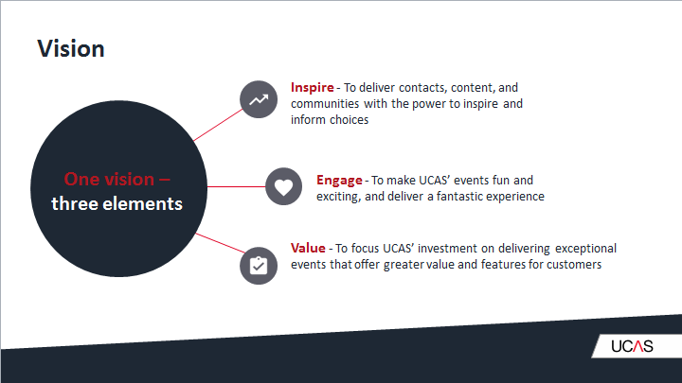 | Vision:  One vision, three elements. Inspire Engage Value. The business of why we do fairs is to help students make their informed choices. It’s more than a website; it’s an experience and a face to face delivery.  To deliver contacts, content, and communities with the power to inspire and inform choice. An event is not worth doing unless you have experience. We have to look at how we drive the overall experience so that students make the conscious choice to want to come to our events as they see the value in attending. And those universities see the value.  Value: to focus UCAS investment on delivering exceptional events that offer greater. Value and features for customers.  The challenge is how we get there.
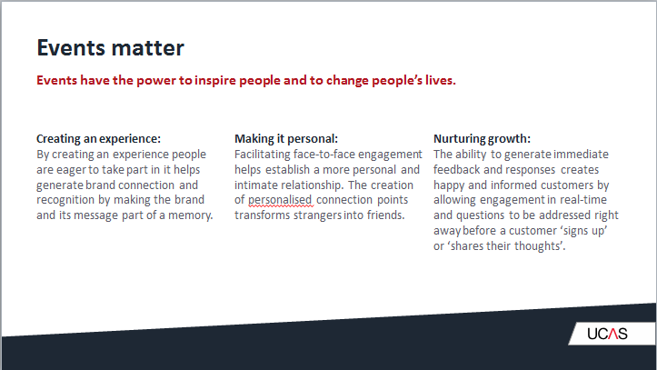 | Events matter: events have the power to inspire people and to change people’s lives.  Creating an experience: we have to make an offering where individuals want to take part. Whatever the message we want to send through an experience, we want to create a memory. The face to face connection is what sticks, and makes a memory.  Make it personal: this is how we create memory. The creation of personalised connection points transforms strangers into friends. Personal, individual, 1-1 connection, they’re more than a number, they’re a person that I understand and I am engaging in that person.
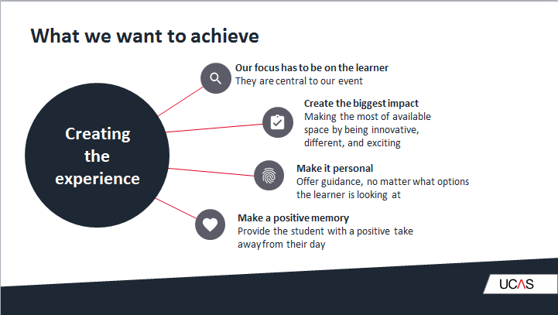 | Our focus has to be on the learner; above the unis. It has to be, they are central to our event, and they’re central to the reason unis turn up.  Create a biggest impact: it’s not enough to turn up and exhibit, an exhibition, to be successful must make an impact. How are we using innovation, creativity, something that makes it different, Something that allows students to create memories, the ability to know what to do next and the knowledge to do that?  Make it personal, individual, one to one, the trick is you can’t make everything personal, it just needs to be, for a time, tailored to them and their needs.  Make a positive memory; going away being enthused, being excited, having a positive take away. Giving them the experience they deserve.
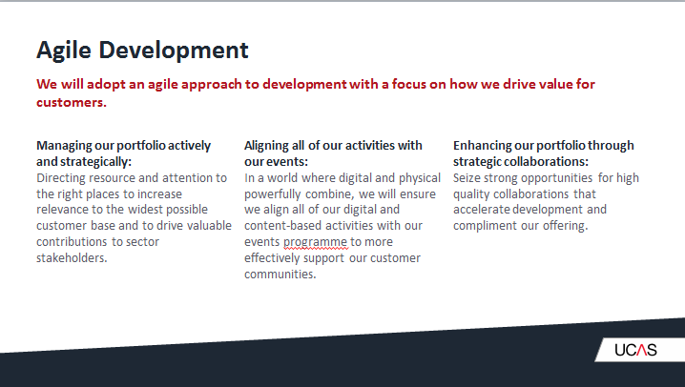 | Agile developmenT: how we steer and develop and grow our exhibition with a focus on value.  We have a resource, we need to make sure this is being pointed in the. Right way. We have a student customer base that is significant in its size; the challenge is how to make our resource relevant to the widest customer base. In the current climate we have the current UG degree but we have other elements: degree apprenticeships. How do we blend and balance so that what we put on an exhibition is relevant.  Give or take every year 730,000 students, individuals we would love the opportunity to engage with. How do we get them at age 17 to our exhibition. But highly unlikely.  There’s a huge number we reach but a larger number we don’t reach.  Aligning all of our activities with our events: in a world where digital and physical powerfully combine, we will ensure we align all of our digital and content based activities with our events programme to more effectively support our customer communities. Looking outside out company, and looking into collaborative partnerships.  There is work to formalise and strengthen the UCAS HELOA partnership. If there is anyone else who can help us to achieve our aims we will seriously investigate how to bring them in.
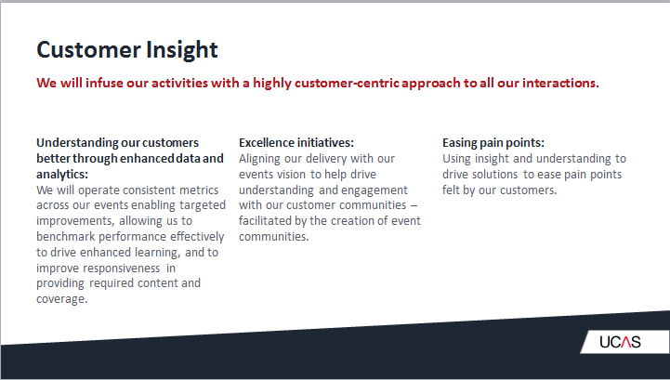 | Customer insight: how to we infuse our activities with a highly customer centric approach  Understanding our customers better through enhanced data and analytics. We need to drive the knowledge and insight based on what we know customers need. Another opportunity is to get closer to our students, creation of a wider community. The means of creating and engagement mechanism that starts before an exhibition starts, pre event engagement which is targeted to give them support AIG to seamlessly flow to at event engagement, and flow into post event and follow it up. Allow other parties who take part to have more knowledge to follow up as well.  This drives through to an increase in understanding of pain points: using insight and understanding to drive solutions to ease pain points felt by customers.
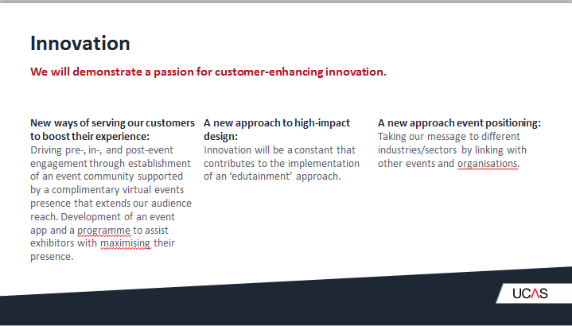 | Innovation. It’s taking that engagement opp and driving it forward.  Outside the exhibition hall. What else can happen?  Virtual events - so this worth exploring. It’s not yet been taken seriously, or viewed as s threat. No one needs to turn up. But it has not yet taken flight.  Digital opportunity is a complementary activity to a face to face activity. It gives slick, clever, high impact activity around those exhibitions. If we have a high student body that we rely on walking into a hall. - We’re unlikely to get everyone. If we compliment that with a digital virtual opportunity (especially for those outside the uK)  Getting them to engage in the nearest possible experience and give them the opportunity to engage and have that insight is something we will explore to increase the impact we can have.  The other side of innovation is about what we can do inside the hall - there’s a value to providing something that visitors enjoy. It’s giving them something more than just talking to universities, making it enjoyable and valuable. Presenting things in a fun and engaging way, what else to we do in an ‘edutainment’ way - something vibrant and different they can make a connection to.  Featuring people, putting zones in, speakers,  A new approach event positioning: some brands focus on engaging customers, so we need to explore how other brands can help us deliver innovation. There needs to be a foundation, and capability to up level exhibition, someone else’s expertise to add value. Innovation will happen, creativity will happen - we need to find out how.
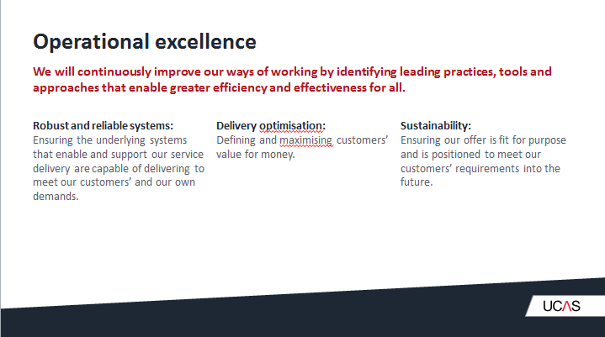 | Operational excellence: pins everything together. Needs to be solid and robust.  It’s about doing what we need to make sure our underlying systems are robust and can deliver what we need, and our customer requirement.  Fostering ideas of value for money ,ours, yours, our customers  Sustainability element, something that works today is no good unless it can be sustained for a long period. It needs to drive the development of what we offer, and helps us to make a valuable contribution.  50 exhibitions attended by c. `60000 students every year to all areas of the country.  Demographics: we are still in a cycle of declining uK 18 year old population while also needing to reach out to a global audience.  Sector there is uncertainty within the he sector together with a broadening range of part ways in to higher education. Degree apprenticeships, government desire to open up technical education in a different ways. All factors have an impact on how we best deliver what we do  Behaviour: we are faced with every changing consumer behaviours enabled by the rapid pace of technology based change. We are competing for attention with an increasing range of topics and activities. Immediate answers needed, competing for time that could be spent doing leisure. Pieces of opportunity are becoming rarer, what drives this and how we respond. This is a massive challenge, we are asking students to interrupt their tie to come to an exhibition, and we need to give them a good reason to do so.  Key themes to discuss: Building reach: how to fully engage with all students and all advisers in all geographic areas>  Delivering impact: how to create a memory while enabling students to make informed choices  Increasing value to all customers: how to deliver our customers value based needs.  It doesn’t work until we being to engage properly with stakeholders in the exhibition, my role now is to talk to our customers, teachers, exhibitors, understanding improvements and challenges etc. How we think we can address challenges
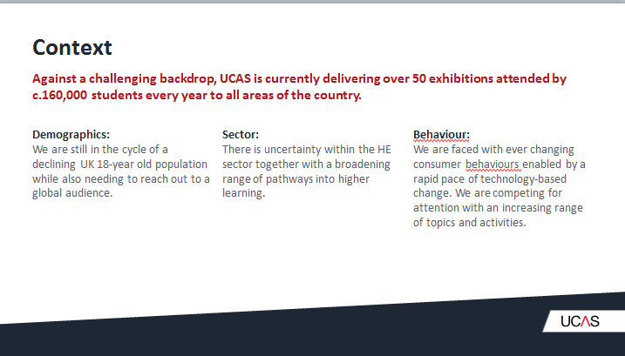 | Building reach: At the moment we have a range of exhibitions of a variety of scales and sizes and running. Is this the right way. What works what to doesn’t. Is there additional work we should focus on, how do we ensure were engaging with as many students as possible.  We could focus on key population centres: other offerings into this centre will run exhibition: London Manchester, Glasgow, and Birmingham. Very small number with a big reach. Supplement it with digital based offering. They want our feedback an s to where it should head.  The working group exists to broaden network to get feedback and to give us the opportunity to say what if, or as questions. Use these networks to that effect and to help UCAS drive their thinking.
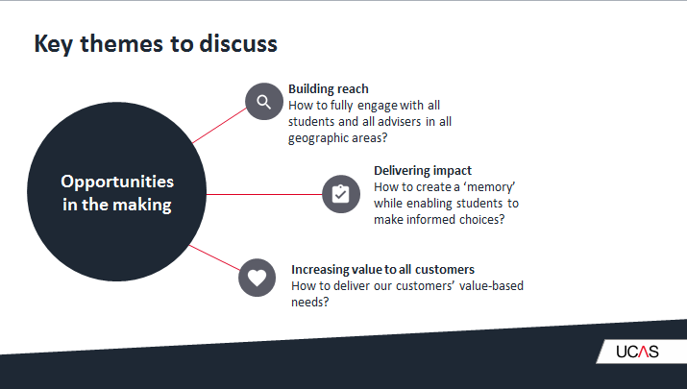
Q & A session as followed. Questions (Q) are from the audience. Answers from Tim are marked as ‘Tim:’ and answers or rebuttals from the audience are marked as ‘A- from audience’
Q: There have been a few challenges with the network of these events and these aren’t advertised with UK. So what is happening with Scotland
Tim: as we speak, next week have site visits with a number of venues. Under normal circumstances, Skills development Scotland has been the main organiser, and they deal with venues. It kept it simple in communication, consistency of approach and tied stakeholder in. Skills development Scotland no longer have this role- so UCAS have taken on the organising function with a lot of the Scots land parties in the same way they do UK. It is very last minute. Scotland will be released very soon. It is not our ambition to not work in Scotland, and the value is in the reach. Our core purpose is to meet our charitable purpose: providing the means so that students can make informed choice. It doesn’t mean 50 per year around the country; it means that we have to do all we can. We have to accept population centres aren’t equal, but they should still get the opportunity to have this impact. There will be gaps and people we miss, how to we drive value and top up our offering with digital.
Q - are there any gaps you’re aware of
Tim - borders and Dumfries and Galway, is the only one unsure of. Dumfries and Galway we’re getting somewhere, but he would need to check.

Q; uni at the end of the alphabet - floor plans, beginning or end of alphabet. Those of us at the end get put in a little room, but it’s not value for us. We don’t get foot fall if we’re put in an external room. Who decided and is there a discussion.
Tim: Alphabet is an issue; it causes issues in terms of universities collaborating and if they are creating a presence that is joint. It is difficult to accommodate everyone - at the moment the alphabet has been seen as the fair way to allocate so that it’s not budget/money driven. One option is to sell off the plan concept, sell best spaces.
Q - that’s what you’ve been trialling with create your future how ha that worked
Tim - it has worked, it’s much simpler. But we’re not here as a commercial enterprise. We need to be mindful of not creating area where budget is more important than anything else.
A – (from audience) what about random
A- (From audience) or just swap every time. A & Y in the middle one time, and not the second time. The pre event work needs to be obvious.
A – (From the audience) Manchester, people were forced one way which stopped flow to the end. Didn’t make any sense, no logic and stops half way.
Tim- In terms of what we’re doing now, a lot of the plans are in place and being firmed up but we will check and see if we can change this. We will take this back to make sure that it is as fair as possible.
Q: Sally from Warwick - fed back about Liverpool, wasn’t worth us attending as it was very quiet. We want to see something off the back off it.
A - it’s a new venue
Tim: it’s a pointless exercise if I ask for feedback but don’t action them, my commitment is that I actively seek out observations and will respond. If we can make quick changes, brilliant, but if it needs investigation, we will do that to improve. Engage, listen and act.
Q: is there any update on the scanning system as there were issues, and there’s 20 % off but I don’t want 20% off, I want the data. What has been done?
Tim - actions have been taken, I will ask team to circulate that. We’ve spend a lot of resource in terms of time and money to make system as robust as we can. It didn’t work as it should have done - there’s a discount to help with the paying. We’ve worked with supplier to make changes and strengthen that, access & data etc. We are in a much better place, we ran some of those improvements during Scottish event, not on the same scale, but operationally it worked and previous issued didn’t reoccur. We are now embarking on a way to move forward: same as now, or do something different. It doesn’t mean that we will make a decision overnight and it will be discussed and tested with unis. One thing out of the working group is that we look at new products, new ways of operating, create environment to do testing to see if it’s suitable.
A - As a host uni when it didn’t work, it was left to us, and it wasn’t managed by UCAS.
Tim- technical support staff onsite, support team in the UCAS office are able to assist. Software support are on exhibition, pre work needs to be strengthened do it doesn’t happen, but if it does, we will have UCAS onsite to help and overcome issued. UCAS to take ownership for problems.

