PQA Consultation – What is it all about?
The consultation seeks views on whether to change the current system of higher education admissions and move to a system of post-qualification admissions (PQA). PQA could see students receive and accept university offers after they have received their A level (or Level 3 equivalent) grades, as opposed to the current system in which students apply up to a year before starting and are made offers on the basis of predicted grades.

Background
- The Consultation document recognises that there has been a lot of progress in terms of access to university to help facilitate student choice increase access to students from disadvantaged backgrounds.
- However, the current admissions system is still creating barriers for students and a recent report found that over 60% of respondents felt that the current system is ‘not fit for purpose’ and 80% wanted to explore allowing students to apply after results are known (3 Higher Education Admissions: The Time for Change (UCU, August 2020)).

Weaknesses in the current system
- Predicted grades made on basis of teachers’ assessment 6-9 months ahead of assessment.
- Applicant must accept offers before level 3 results, meaning they are less informed.
- Evidence that applicants from disadvantaged backgrounds ‘undermatch’ and end up studying courses, or at institutions with lower entry requirements than ones they could have studied at.
- The use of conditional unconditional offers and other undesirable admissions practices such as material inducements to persuade students to enter certain courses.

Considering PQA as a Solution
- Time to explore PQA as a solution to address challenges with the current system: that it is complex, lacks transparency, works against the interests of some students, and encourages undesirable admissions practices.
- Applicants having completed level 3 quals and knowledge of results could put students in a better position to make decisions about their future.
- Support for a PQA system in some form from the Sutton Trust, UUK and UCAS acknowledge that now is the time for reform to be considered.
- DfE recognise that whilst having benefits, PQA presents challenges in implementation which may result in the policy being unviable.
- PQA would create major administrative changes and have practical implications for other parts of the education system too, not only HE.
- DFE intends to work with the whole education sector (Higher Education, Further Education and Schools) to assess the case for PQA by consensus. DfE will collaborate extensively with UUK and the HE sector on the proposals. Impact on devolved administrations will also be considered.

The case for change
Inaccuracy of predicted grades
- Grades often over predicted: UCAS end of cycle report 2019 showed that of UK 18-year-old applicants with at least three A-levels who were accepted on to a place, 79% of individuals had predicted grades which were over predicted.
- Adverse impact on high-achieving disadvantaged students and ‘undermatching’: High-achieving disadvantaged students are more likely to be under-predicted than high-achieving advantaged students and 6.9 percentage points more likely than their peers to enrol on courses where they are more qualified than their peers. PQA could help to address this as applications would be made to providers based on achieved grades, and under this system previously underpredicted disadvantaged students would have the opportunity to apply to the most selective providers and courses, therefore levelling up access to higher education for disadvantaged students.

Simplicity and transparency
Complexity of admissions system means it is often poorly understood by applicants and their influencers, particularly the case for disadvantaged learners.
- Mismatch between course grades advertised and the grades accepted: In 2019 UCAS identified that 49% of 18-year-olds who sat at least three A-levels, were accepted with lower grades than those advertised. Issue here with transparency. DfE endorse proposals (from OfS and others) that providers publish full information about the qualifications achieved by students entering courses in previous years.
- Complex additional admissions processes: Clearing and adjustment have been designed in part to address issues related to students achieving above or below their predicted grades, or changing their minds. Clearing adds complexity and adjustment is underused and more likely to benefit more advantaged students.
- PQA could offer a clearer and potentially simpler process for managing applications: Depending on the design of a PQA system, it may also offer higher education providers a simpler process for managing applications. Different designs also have the potential to reduce the amount of work teachers do in writing references and helping students write their personal statements.

Unconditional Offers
PQA could eliminate use and adverse effects of unconditional offers outlined below.
- The risk of reduced attainment and university continuation rates: UCAS analysis shows unconditional offers have negative impact on A-Level outcomes for students.
- The impact on disadvantaged students: POLAR Q1 (most disadvantaged)
applicants are more likely to receive an offer with an unconditional component.
- Constraining choice: Students accepting offers solely on the basis of them being unconditional potentially deprive themselves the chance to consider other universities.

Implementation
Whether or not to deliver a PQA system, and the most optimal model for delivery, will depend on the responses we receive as part of this consultation and the broader discussions we have with key partners and those who would be impacted by reform. As part of this, we want to fully understand the potential costs, adverse effects or barriers to implementation.

Not in scope – the following are not in scope as part of the consultation:
- Level 3 (A level and equivalent) assessments.
- The use of UCAS as an application tool for undergraduate courses.
- The application processes for postgraduate courses.
- The need to have regard to the autonomy of higher education institutions in determining the criteria for the admission of students and applying those criteria in particular cases.
- The Government’s wider policy on Access and Participation, including the approval of Access and Participation Plans, as regulated by the OfS.

PQA Delivery and Implementation
- Variety of ways PQA could be implemented, DFE recognise challenges for key stakeholders including HE, FE and schools & Colleges.
- Some proponents of PQA have suggested offers could take place form August onwards with no changes to level 3 results days, but with HE terms starting between November and January.
- DfE have ruled the above out for the following reasons:
  - considerable gap between the end of school/college and start at university,
  - A short first term if starting in November and January first term out of sync with other nations causing potential issues for international students
  - As the exam/result timetable in other northern hemisphere countries usually means that students receive their results in the summer, it could have implications for where international students choose to study.
  - This model could involve a considerable loss of income for HEIs in the transitional year (up to three months’ worth of tuition fee and accommodation revenue)

Proposed Models of PQA system – Overview to models can be found in appendix A below
Model 1 – post qualifications applications and offers

‘Post-qualification applications and offers’, with a longer application window created by moving results dates forward to the end of July and HE term dates back to the first week of October.

- Applications and offers would be made after results received.
- Earlier results and university term starting no earlier than first week of October, creates 6-week window for processing offers and a 10-week first term at university before Christmas.
- DfE recognise that courses where additional entrance tests are required (e.g. portfolios, interviews) would need to be accommodated into this system.
- Recognises challenges around shifting exam timetables and impact on teacher workload and ability to support students.

Model 2 – pre-qualification applications with post qualification offers and decisions
Applications made during term-time (as now), but offers made after Results Day

- Students apply in the normal way, and at more or less the same time as they currently do. However, applications are held in the system until the results dates (which could be brought forward by a week or two) and offers are only made once results are known.
- Under this model students would require significantly less support over the summer with their applications. However, some students may require support in deciding which offer to accept.
- In order to ensure that no offers are made in advance of the results day, DfE envisage that the full application could be held by a third party such as UCAS, and then released after Results Day, with some headline data released to providers to enable the planning of intakes, and facilitation of additional recruitment procedures, where these are necessary.
- This model would have implications for, amongst others, higher education providers and sector bodies, schools, FE colleges, students, teachers and organisations involved in the delivery of qualifications. Through this consultation DfE plan to gather evidence to understand these implications in more detail and to minimise any adverse effects should we move forward with implementing a PQA system.

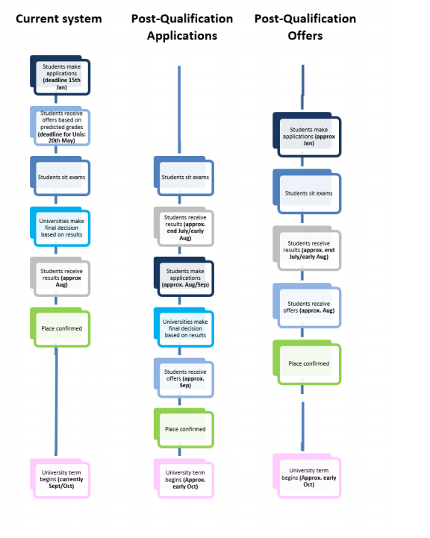
Appendix A – Proposed PQA Models

