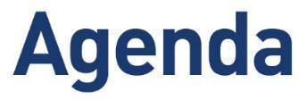

HELOA North East, Yorkshire & the Humber
Group Meeting - Online
Friday 27th February 2026

10:00: Welcome

10:10 - 10:40: Managing a regional team
Lydia Stride and Kelsey Blemings, University of Sheffield

How do you manage a team that isn’t all in the same place? Hear from Kelsey and Lydia at the University of Sheffield, as they share how they lead a hybrid team of officers & interns across the North & South. From the practicalities of hire cars, costs and contracts to trying to keep everyone feeling like one team, wherever they’re based!

10:45 - 11:30: Keep on Movin'
Elliot Newstead, De Montfort University

On average, people spend *roughly* four years in a job but how can you be preparing for a job you don't know about yet?Have you taken a good look around? Are better things coming your way?This session will explore the journey from officer to manager to department head and consider how, within our sector niche, HELOA members can think about exploring that *next step* (spoiler, it doesn't always have to be 'up'). Remember, things will be alright in the end.

11:30 – 12:00: Group Meeting
- Apologies for absence
- Matters arising from May meeting
- Update from Chair (inc. UKC Update)
- Updates from Vice Chairs
- Any other business

12:00: Final Information and Meeting Close
Please note that sessions and timings are subject to change.
Next meeting:

