HELOA North West & Northern Ireland, Virtual Group Meeting, ‘HELOAfromHome’
Session Notes - 07.09.2020 – 11.09.2020

Institutions Registered:

Edge Hill University (8)
University of Chester (1)
Lancaster University (6)
University of Cumbria (1)
Liverpool John Moores University (5)
Manchester Metropolitan University (3)
University of Central Lancashire (7)
University of Liverpool (3)
University of Salford (4)
Queen’s University Belfast (1)
Aberystwyth University (1)
Total Registrants: 40

The session notes below were written and compiled by a variety of reporters, therefore some formatting differences may be present.

- Introduction, Group Update & ‘HELOA-Goodbye to 2019/20!’ Discussion – p.2
- “Practitioners Hour” – p.5
- Widening Access to Postgraduate Study – p.8
- ‘Out-of-reach Outreach’ – p.9
- ‘What are NW&NI universities doing to support BAME students?’ – p.12
- UCAS Events Working Group Update – p.14

- Introduction, Group Update & ‘HELOA-Goodbye to 2019/20!’
Chris Mullen, HELOA NW&NI Group Chair, Edge Hill University

Group Chair update from Chris
- HELOA is a registered charity in Scotland now – so HELOA has charity status in England, Wales and Scotland now
- Jonathan Atkinson (HELOA UK Chair) will be putting together a wording for school requests asking to pay to attend – institutions are welcome to use it or not to use it
- HELOA VC Administration & Membership’s Membership Survey – main finding was that members see the financial value of HELOA and COVID isn’t affecting membership renewals
- National Training
  - There are online events coming up; National Conference is cancelled for 2021
  - Since May 2020 – 56% of HELOA members have engaged in training activities – shows how beneficial this is to our roles
  - National training team looking into providing accredited training
  - Professional Development Conference and New Practitioners Conference coming up online – great opportunity for new members or experienced members of your team – bookings not open yet but open very soon
  - 2022 National Conference will be at Carden Park, Chester
  - UK Committee looking at online AGM for January 2021 – requirement as HELOA is an organisation, likely having one member of each institution in attendance and vote
- Amanda Kenningley introduced herself as UK VC Group Development, will finish her Group Chair role on 16th September 2020
  - Looking into how she can work with Group Chairs closer and bring Groups together
- Blind elections going forward – wouldn’t see who is going for the position, just their application – encourage diversity and involvement at regional and national level
- Project around ‘Non-Publicly Funded Institutions’ still going ahead – deciding what type of membership they will have and what rights they have as, for example, ‘associate members’ e.g. are they allowed to vote in elections?
- Question put to attendees: Do members feel like they hear enough from us?
  - Yes - a good amount. Members like the videos that Chris produces but would also like a summary of the content in text.
- HELOA Mentoring Programme
  - Still open to get involved
  - Mentoring Conclusion Google Form now exists for relationships that have finished – can indicate here whether you want to be entered into the pool again
- Publication Project
  - Still need ‘How to say no’ author and ‘Talking about the importance of your role to your institution’ author to volunteer and produce those 500-word articles
  - Not producing it in physical form – going to be online version
  - When members sign up to HELOA, it will be included in their welcome pack
- Mental Health training
  - Can’t provide update yet, it’s paid for and booked but will get dates over when everything is safe
Review of ‘Current Position Survey’ Results
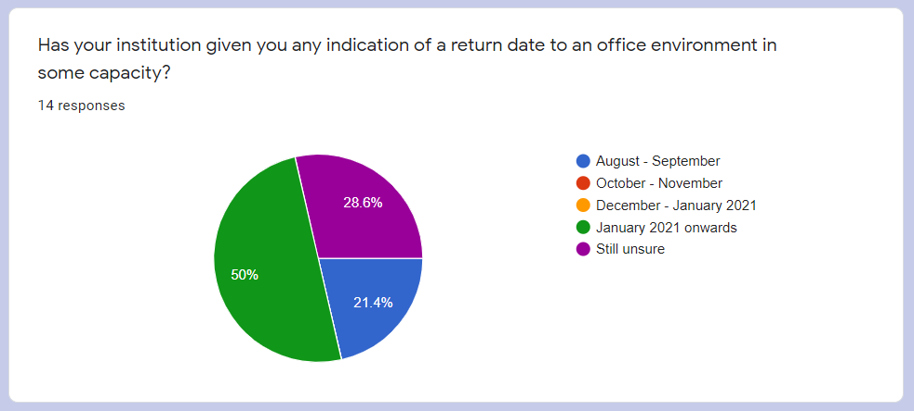
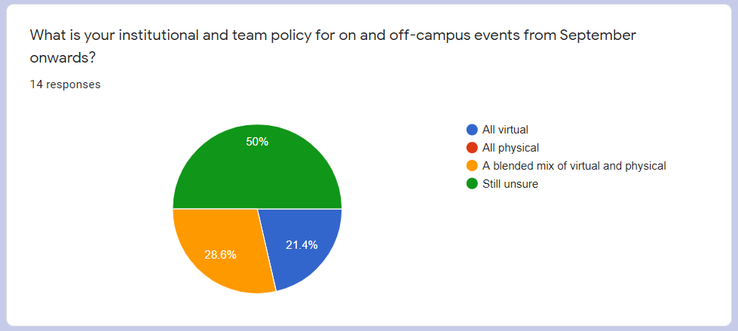
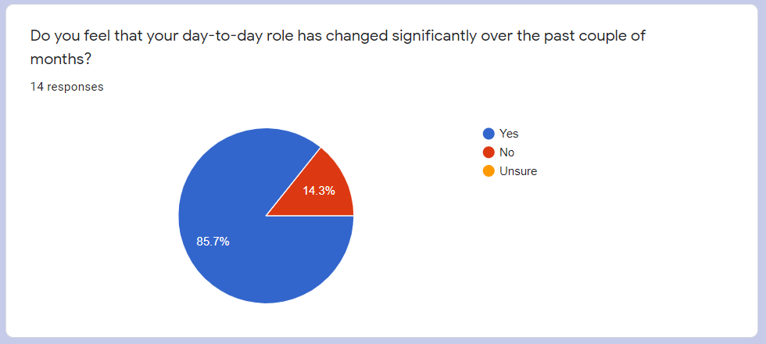
- 50% of respondents going to be returning from January 2021 at least, with 28.6% still unsure and 21.4% between August and September 2020
- Format of delivery is mostly unsure (50%) but then blended mix (28.6%) and then entirely-virtual (21.4%) – none entirely-physical delivery for any institution
  - If there are any physical deliveries, have you had to create any extra risk assessments?
  - We would welcome feedback from institutions on how delivery is going
- 85.7% of respondents felt their role had changed over the past few months, having to learn new skills etc.
  - Members who completed the survey noted they had to:
    - Learn new ways of delivery and be more creative
    - Support virtual open days more
    - Learn to work regular hours compared to erratic, unpredictable hours
    - Fill in the gaps in other teams
    - Spend all day confined to a laptop
    - Engage in more research and planning
    - Conduct a lot more admin tasks meaning less time with target audiences

HELOA-Goodbye to 2019/20! A Year in Review - Discussion
- The following discussion topics were put to all attendees verbally
- “How have we been managing with the shift to virtual delivery?”
  - Not able to see interaction from audience or their reaction to your delivery is a bit unnerving, can’t ‘judge the room’
  - Unnerving when schools record the sessions
  - In some ways, virtual delivery is good, as those who are attending have to book on – so in theory, they WANT to come
  - Attendees tend to ask more questions, as it’s text-based compared to verbally raising a question in class
  - Schools have enjoyed having access to recorded webinars they can show students later on
  - It’s amazing that we didn’t think of doing virtual delivery beforehand!
  - It’s good for skillset learning and future-proofing ourselves, we’re now literate on these many different platforms
  - Schools are also now literate with virtual delivery and platforms, means they may be willing to accept offering of virtual delivery
  - It’s important to set the ground rules about our virtual delivery – this is what we’re comfortable with, don’t be pressured into delivering something that’s convenient for the school but you’re not confident doing
  - We don’t have a captive audience anymore – they’re at college etc. during the day, will they dial in in the evening? Probably not
  - When is best to deliver sessions? They have different lunchtimes, could do after-school clubs etc.?

- “How was the summer/results period?”
  - Experiencing helping with queries and admissions has opened my eyes to how it is out there
  - Been good to get some training in other areas but also in areas you’d like to be interested in e.g. online courses, Google Garage
  - You have to learn how to do new things
  - Student Recruitment teams are the Swiss Army Knife of universities – they’re the teams that the university will turn to for a lot of queries and requests, and we usually say ‘Yes!’
  - We’ve become used to dealing with external companies directly and reacting to their format and quality of delivery

- “Transition into 2020/21”
  - Talks delivered to school groups at a distance may be COVID safe
  - Delivery is governed by what’s happening in the wider world e.g. lockdowns
  - Liverpool John Moores can travel but not allowed to go to Northern Ireland, although they’re currently pushing to be able to
  - Chester still waiting for clarity and advice around on-campus visits – carrying on with virtual delivery and doing campus tours
  - Lancaster not travelling in September but potentially afterwards, although staff members don’t feel personally comfortable
    - Will those comfortable to work take on more workload?
  - Remote officers now feel like everyone having to work from home has made it better for them – it’s made the transition easier as everyone is in the same boat with virtual/remote delivery
  - Having an office-based role allows for skills for progression and knowledge to be passed on in an ‘osmosis’ environment
  - Being remote might make staff feel like they’re missing out on the social side of being in the team
  - Slightly concerning that the Virtual UCAS Fairs demand staff be present 7am – 8pm

- “What are we looking forward to?”
  - Seeing each other again!
  - Having a different attitude towards working; willing to do different types of events and with different platforms
  - Feeling valued
  - Working more collaboratively with remote teams or other universities as well
  - Appreciating everything a little bit more, feeling lucky about what we CAN do

- “Practitioners Hour”
Jon Cheek, UniTasterDays; Fiona Curry & Jack Clare, HELOA Partnerships; Stephen Jones & Kev McMullan, Student Loans Company
Jon Cheek – UniTasterDays
- UniTasterDays is around to help students find universities, where there isn’t already-existing good relationships (like RightMove for schools and universities)
- Schools can request university events and can sign up to a weekly events-by-email newsletter
- 4000 teachers are registered to this newsletter, which comes out on Wednesdays
- #UTDIAG Advice Blog – recommended that practitioners look at this and can also contribute to blog content (only need the text, UniTasterDays do the design etc.)
- Universities can list general and subject-specific events for schools and students, including online events – UniTasterDays always appears at the top of Google for university events searches
- New academic year campaign going to 60,000 teachers this year – if you have any that you want teachers to be aware of, put it on UniTasterDays
- UCAS Taster section is linked with UniTasterDays via a feed, as well as a feed on HELOA
- The Connect Listings Tool – UniTasterDays can provide this free for your website which lists your events only, embedded into your university website – UniTasterDays provides the code to include on your website
- ‘UniTaster Tuesdays’ webinars – 12-2pm every Tuesday with two universities at each event – wanted to launch something that would be the go-between amidst the universities running their events and their schools
  - Extremely popular events – always impartial and universities don’t pay to attend
  - Schedule now running until the end of December 2020
- Lunchtime Learning videos on the UniTasterDays Advice Blogs section – recommended that members view these, expert speakers from across the sector
Fiona Curry and Jack Clare, HELOA Partnerships
- Much of this session was described via the presentation slides, so please make sure to read those alongside these notes.
- Why are we here?
  - Raising awareness of who HELOA works with and why
- Partners
  - Student Loans Company – HELOA feeds insights to SLC, their team don’t necessarily have those conversations with students and parents and other key stakeholders, so HELOA feeding back those common questions is really useful for SLC
  - UCAS (Headed up by Elliot Newstead) – UCAS Events really impact all of us so having that mutual exchange of feedback and early-as-possible feedback is beneficial to contribute, it’s an ongoing relationship with UCAS; There is a new Head of Events at UCAS, too.
  - The Student Room – relationship that was expanded last year, re-engaging with them at the moment as HELOA signed a Memorandum of Understanding with them – always keeping in mind the benefits for the HELOA membership.
  - Commercial partnerships need to add value to members and bring us benefits – income really helps with it as well but it’s all about the membership benefits
    - Supporting training events (e.g. National Conference, PDC and NPC)
    - Digital Marketing opportunities
- Sponsors – more about generating income to feed back into the organisation and remain sustainable, to continue to provide high-quality training
- Collaborators – not necessarily formal or getting income but about sharing best practice around knowledge exchange
  - Wonkhe, Office for Students, UniTasterDays for example – they’re less-formal agreements and sit on various advisory boards together
  - HELOA is always keen to communicate and work together with collaborators
- Partnerships Roadshow – team visiting different Groups across the UK
  - The team want your feedback on these partnerships and if there’s anyone you think HELOA should be partner with
Student Loans Company – Stephen Jones and Kev McMullan
- What’s happened since COVID-19?
  - C.2500 employees at SLC had to move very quickly to an entirely home-based team
  - It’s been difficult for some students to get evidence to them – this can be sent in directly electronically now
  - Removed the requirement for a form to be sent with birth certificate if they don’t have a passport – they don’t need to look for a professional person to confirm they recognise them
  - A lot of people have been made redundant – usually there would be a small number of income numbers changing mid-year to alter the means-tested elements of the maintenance package (dropping more than 15% may mean students are entitled to more support) – there will be more this time round
  - Ongoing updates at the www.gov.uk/slc website - speaking constantly with governments across the country
  - The situation continues to change, and challenges constantly appear; there’s a need to understand clearly what those mean and how SLC can best support those students
- Application Stats
  - Around March/April, there was a big reduction in continuing students putting in an application form – this was very peculiar
  - Applications for Student Finance usually peak at the deadline (May)
  - Most common queries on deadline day (see presentation slides)
    - Most-popular issue was that eligibility sections were incomplete e.g. residency status, so maybe universities can create more guidance on this towards the May deadline?
    - Issues around the middle of August – awaiting validation was the main source of applications not going through to be approved (needing financial information, current year income, marital status etc.) – students usually need help on this aspect around August, so may be useful for universities to create guidance on this at this time
  - Over 60% of student finance applications are from students living in the ‘Elsewhere’ category, then with parents, then London and then studying abroad
- Work on 2021/22
  - Big question around Brexit and the impact on EU students, as well as students looking at studying in the EU – we don’t have the information at the moment
  - There’ll be a change to the Disability Support Allowance – aligning towards undergraduate and postgraduate support (all students will have a single-access fund of £25,000 throughout the year)
  - Financial Memo has been released, looking at what the funding package will look like into the next cycle – maintenance loan increasing by 3.1% in line with inflation
- Any changes to funding for next cycle?
  - Tuition Fee loans remaining at £9,250
  - Maintenance Loan increasing in-line with inflation (3.1%)

- Widening Access to Postgraduate Study
Rowena Piers, University of Edinburgh & Al Blackshaw, University of Strathclyde

It is recommended that readers view these notes alongside the slides provided.
The session aimed to equip members with tools to empower them to make changes on how they promote Postgraduate Taught and Postgraduate Research courses.
Rowena completed a research project on interdisciplinary mixed methods, which was a collaboration between careers departments and widening access at Strathclyde.
What are the barriers that exist to PG study?
- Location
- Lack of centralised application process
- Family and caring commitments
- Finance
- Career pathways
Quantitive findings:
- Motivation to study at PG level?
  - Personal progression
  - Pursuing an intellectual interest or academic career
  - PG Taught students are more likely to be more motivated
  - See slide 5 for full results

- Funding PG study
  - Most people used a combination of personal savings and scholarships – the key take away is the earning potential for PGT students after graduation.
  - It is recommended that universities do a full audit of what postgraduate financial provision is available and see if it is fit for current purpose, or could be re-purposed elsewhere.
  - See slide 7 for full results

- PGR recruitment and widening participation efforts need more buy-in from academics. Use current student cohort as promotion.
Concerns and barriers:
- The overall cost of living
- Imposter syndrome
- Belief in own academic ability
- Health
- Fear of further debt
At least 40% of PGT and PGR students considered withdrawing from the course during their studies.
First-generation students are less likely to receive scholarships from employers compared to students who have parents that attended university.
Universities could convince alumni departments to ring-fence funds for a needs-based scholarship.
Postgrad scholarships are usually based on merit (such as alumni awards) and not individual need.
74% of first-generation UG’s continued with study at PG level. SIMD (similar to POLAR data, used in Scotland) is not a good example of a representation indicator.
Student Union events are usually inaccessible to PG students. There is a requirement for their own social spaces.
PhD’s are being valued more in industry, as well as in academia.
PGR students can suffer from a sense of isolation.
The closer the student lives to the university campus, the significantly higher the demand for mental health support. They’re likely to be living away from family and their traditional support network.
There is not enough honesty in the information applicants are provided with. A lot of information is withheld.
Financial barriers – there are struggles with self-funding and stigma about the perceptions from others who are self-funding.
Moving forward (what can universities do?):
- Consider setting up a first-generation student society.
- Review your postgraduate scholarships and bursaries.
- Maybe stop throwing money at the problems and instead ‘throw things’ at them, such as laptops, devices, work experience etc. – not everything can be solved by money!
- Better information required on applying for PG.
- Need to create a sense of community from early on, for distance learning as well. Consider peer mentoring for incoming PG students.
Take-aways:
PG is more diverse than UG.
Funding is important.
First-generation students suffer the same barriers as WA/WP.
Need for universities to provide more information – how to apply, funding etc.
Transition between study levels should not be treated as insignificant!
Don’t default to SIMD/POLAR as indexes of deprivation, there are many other factors at play.

- ‘Out-of-Reach Outreach’
Nick Cave & Oliver Rosetti, University of Leicester; Kirsty Wilkinson, Loughborough University; Sophie Palmer, Revolution Viewing

Nick Cave & Oliver Rosetti, University of Leicester – Our Digital Approach
- Ways of working
  - Tried most platforms for digital delivery e.g. Teams, Zoom, Adobe Connect, Sutton Trust’s platform, Blackboard Collaborate Ultra
  - Got the chance to join working groups on projects outside of job descriptions
  - Only work 9-5, not afterwards or before
  - Meetings capped at 50mins max – help reduce the amount of time in front of the computer
  - Given an additional ‘digital detox hour’

- Virtual Offering
  - Online open days and digital offer days on platforms like UniBuddy
  - For live video outreach, relied mainly on Microsoft Teams
  - Very useful to have live chats with teachers and advisors to get an insight into the thoughts of schools and colleges staff

- Digital Summer Schools
  - Don’t try and recreate a physical event with an online one
  - Digital capabilities have allowed for increased capacity at certain events, like Summer Schools, which would have been previously limited by physical space
  - We’re all learning as we go along – don’t be afraid to say: “No, this isn’t working or isn’t going to work… let’s not do it”, even after planning stages
  - Students don’t use Twitter – they mainly engage with Instagram, so learn how to use it!
  - Lessons learnt:
    - Choose the right platform for that job, and test, test, test!
    - Don’t be afraid of being rough and ready
    - Be prepared to sit in front of your computer for a long time
    - Digital Inclusion – insights from Sutton Trust, take a look at this

Kirsty Wilkinson, Loughborough University – ‘HE Unboxed’
- www.lboro.ac.uk/unboxed
- Programme has been in development for around 5 years, was useful for when COVID hit
- Loughborough’s flagship WP programme, aimed at Key Stage 4 learners, with full lessons (including plans, USB stick, materials etc. included)
- Once finished with, the boxes are posted back to Loughborough
- In response to feedback, LU developed boxes around careers and employability
- Works well with harder-to-reach cohorts, such as refugees and care-experienced students
- Completely free to access for schools – if something goes missing, they’re very low cost to replace so wouldn’t charge the school
- Over 8000 learners engaged as of March 2020, at the cost of £2.38 per learner
- When schools order a box, Loughborough requests postcodes of the students who will be using the boxes, to measure WP indicators (65% of learners identify with at least one WP cohort)

- Impact of COVID-19
  - Schools not physically meeting so don’t want to make use of entire suite of boxes
  - LU have adapted existing materials for ‘HE at Home’
  - Target audience consequently widened by this, making it accessible for parents or older siblings who may want to help the students with the activities, such as adding or removing activities on lesson plans
  - 41% of ‘HE at Home’ engagement showed at least 41% of WP indicators according to postcode (would likely be higher with other markets)

Sophie Palmer, Revolution Viewing – Digital Content: Reaching Outreach
- WP backgrounds were heavily influenced by marketing compared to more privileged students, who were aware they were being marketed at
- WP students genuinely more interested in exploring more of the universities and everything they have to offer, meanwhile more privileged students were using online/virtual content to validate a preconception
- WP students needed more guidance on understanding the offering at university, meanwhile richer students definitely thought they were aware of everything university could offer them
- WP students wanted to focus on fitting in, so looked at social side of university and the teaching spaces; at first they didn’t understand how lectures and seminars were going to be held

- Commonalities:
  - Accommodation is important, make this prominent on website! WP students were very worried about how they could afford decent accommodation – put information on grants/bursaries/scholarships front-and-centre on website
  - Location importance – talk about where the campus is, promote the local area and the lifestyle students will have
  - Quality and authenticity – a lot of students would associate the quality of website content with the quality of experience they would get there. Make sure it looks like you’ve really invested in high-quality marketing. However, they also want authenticity and honesty – put the student voice front and centre.
  - Content duration – generally, students wanted video content at maximum 60-90secs but course-specific videos, they’d watch up to three minutes. Those earlier in the recruitment process would prefer 90 secs, those already in the application journey would be willing to look at longer videos.

- What do students think about virtual tours and virtual open days?
  - Three quarters of students surveyed didn’t even realise virtual tours and open days existed! Drops to 55% in Y13 – more aware by that point.
  - Most students would expect universities to have a virtual tour or open day and would find it useful in selecting their perfect university
  - Vast majority of students who watch these virtual offerings would be more likely to attend an open day or applicant day – this was especially important for students within community colleges who could only afford to go one or two university open days
  - Most would expect to see it on a university home page, with links also on ‘visit us’ and accommodation webpages
  - A lot of the students would prefer to email a university rather than speak on the phone, so they could write some questions and copy and paste them to multiple universities
  - Most would want this content available 24/7, rather than having to log on at a particular time – this content would be useful to them through the whole application process
  - WP students said that they had attended an open day and if universities had a virtual tour, they would show their parents who hadn’t been able to come, to get them excited and engaged in the prospect of them going to university. More privileged students saw universities blend into one after visiting many open days, so virtual tours would be a good way to discern between different universities they’d visited.
Contact details of speakers, who are happy to be approached:
- Sophie Palmer - sophie.palmer@revolutionviewing.com
- Kirsty Wilkinson - k.l.wilkinson@lboro.ac.uk
- Oliver Rosetti - or45@leicester.ac.uk
- Nick Cave - nlc13@le.ac.uk

- ‘What are NW&NI universities doing to support BAME Students?’
Reena Kaur, Edge Hill University & Catherine Shillito, Liverpool John Moores University

- Catherine
  - There’s been a big focus on Black Lives Matter and universities have had to do more than ever before to support certain cohorts
  - Lockdown has actually increased interventions and meetings with BAME communities that LJMU have worked with
  - You need to find a common ground and make it relatable to those communities
  - Recommended that you tap into other groups in the universities that may be able to help you access those communities, such as religious groups
  - LJMU kept subject-specific WP support localised within 5 miles, and 50% of attendees on the Law subject taster (delivered alongside DWP law firm) were from BAME backgrounds
- Reena
  - Hers is a new role created in line with Edge Hill’s APP (Access & Participation Plan), university didn’t recruit well from BAME communities, so this role was created to help identify why
  - Reena started speaking with other WP and BAME support staff across NW universities e.g. Lancaster, before moving on to talk with various colleagues across the UK
  - Started doing work with current EHU students, rather than focusing on potential applicants – need to identify what barriers they faced on the way in
  - Did work through focus groups
  - BAME student from Manchester said she wouldn’t look west of Manchester because “they’re all white universities” – there’s some troubling preconceptions about these universities that need to be addressed
  - This type of work cannot be done alone – collaboration is essential and it’s essential to advise students towards the right university for THEM
  - BAME students will usually go towards professions or a degree with a definite job behind it; it’s a cultural thing, such as Medicine, Law, Management etc., rather than creative arts for example
  - Build students’ cultural capital through work with museums and theatres
  - BAME students are least likely to access support from student services and academics – a big piece of work is needed to build BAME students’ confidence in approaching these services, not just focussing on academic skills
  - Improve campus culture for new students and existing students – if BAME students come to a university which doesn’t cater for their culture or the existing students aren’t aware of these traditions, it will impact their experience
- Breakout room – what are universities doing?
  - “I’m not aware of what our university is doing” – this, alone, is a strong message
  - One big issue for strict Muslim communities was Student Finance, they cannot technically take out the student finance loan as it accrues interest
    - Government promised to look into Student Finance system friendly for Muslim students back in 2014, still not been done
    - Students would have to approach mosques or have crowd-funding initiatives to send them to university
  - LJMU’s Law Factor programme
    - Y12-13 students, working with DWF solicitors – take BAME students to the solicitors to get an insight into the profession of Law – has worked really well
  - LJMU working with construction and engineering company to increase awareness of pathways into that profession
  - Finn, regional officer from Salford, living in Essex
    - I work with BAME students a lot as part of regional role
    - Previous employment across different universities has helped my awareness, such as at Uni of Sussex, which has over 140 different cultures on campus
    - It’s important to tell prospective students that different cultures will be present with them, such as in their accommodation and they can bring this to make an exciting experience e.g. cooking Irish breakfast, bringing Welsh cakes
  - BAME students will stay local for many cultural reasons
  - If there’s a heritage to that community, that’s important to point this out – not just coming to those communities to say we have and to get them to come to the university
  - At points, in marketing, you only see BAME students in the ‘international’ pages – have honest and open conversations with marketing to address this
  - Lancaster’s race equality network – pushing the university towards the race equality charter

- UCAS Events Working Group Update
Ellie Wharfe, Manchester Metropolitan University and NW&NI Representative on HELOA UCAS Events Working Group

- Don’t email UCAS individually with issues – email Ellie and put it through the collective NW&NI view
- UCAS has a new Head of Events, she’s really on-board with working with HELOA and customers
Virtual Events
- Physical events not happening in the autumn term – have become virtual events instead
  - There is a separate Code of Conduct and a Safeguarding Policy – members attending should read through this, if it doesn’t cover certain areas then let Ellie know and she will feed back to UCAS
- There’s a need to improve quality and timeliness of communication from UCAS
  - They need to let us know that if something is being worked on, don’t leave us ‘in the lurch’
- Subject themes for virtual events has been addressed and that some are missing, Working Group working with UCAS to see if these subjects can slot into existing events or new ones created
- UCAS said subjects like allied health will be covered in next round but they might look at getting them in this round of events
- Earlier starts and later finishes for UCAS Autumn virtual events were to make sure international audiences were covered
  - UCAS needed reminding that most of our teams don’t work with international audiences – would be better to have an international-specific event
- 10 events currently proposed for the spring term
- Working Group raised that it would be good to have booking numbers in advance of events
  - UCAS looking to share this in advance if they can
- Working Group considered an opportunity for UCAS to create a video about making the most of a virtual event – universities could support and promote this resource
Physical Events
- Would be good to know a Plan A/B for physical events taking place in 2021
  - UCAS have asked the Group for a timeline that institutions work towards for physical events
  - Members are encouraged to provide these timelines and other feedback
- The Group considered adding a tag to the scanners as to whether a prospectus should be sent (physical or digital) to the enquirer, in case universities cannot provide physical collateral on the day
- 2021 calendar – the Group raised that UK University Search and UCAS Midlands event clash
  - This is still an outstanding decision
  - Staffordshire has been moved to 11th June 2021
  - London has been moved to 29th – 30th March 2021 (currently clashes with Dorset)
  - Lincoln has been moved to 31st March 2021
- Universities may not be able to hire devices – the Group has stressed the importance of letting universities know this as soon as possible
- Discussions around external factors, like COVID-19, will be discussed at the next meeting on 3rd December 2020
- Next year’s physical events will use the same scanners
Pricing
- Still a lot of confusion on prices and credits – email address for queries regarding this is: eventssales@ucas.ac.uk
  - 2021 pricing has changed – UCAS said most institutions won’t be affected
  - Manchester, London and Birmingham are outside of the subscription package and are being treated as a premium – most universities will attend these, so will likely have to pay extra
- UCAS provide HELOA with tracking reports
  - UCAS want to know if there’s any information universities/HELOA want to know from them? May have to pay extra for access to this, though
- Next HELOA UCAS Events Working Group meeting will be on 3rd December 2020
- 2021 physical events booking opens on 20th October 2020

