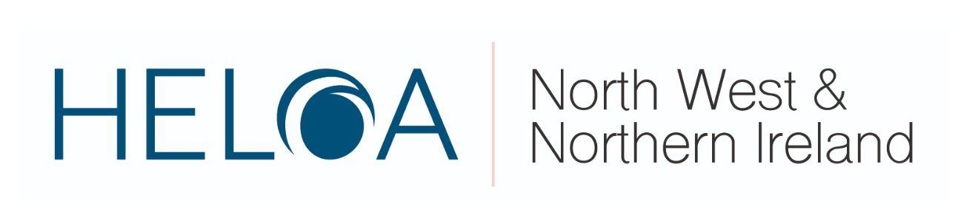
HELOA NW & NI Group Training Day
Thursday 5th December 2019
Victoria Gallery & Museum, University of Liverpool, 9:30am - 4:30pm
9:30 - 10:00 | Arrival & Host Introduction  Jack Leggate Theatre, 2nd Floor, Victoria Gallery & Museum (No. 421, Ref. D7)  Jonathan Atkinson, University of Liverpool & HELOA National Chair and Chris Mullen, Edge Hill University & HELOA NW&NI Group Chair.
10:00 - 10:30 | Ice-breaker Activity:  “Giving the GIF of Christmas”  Jack Leggate Theatre, 2nd Floor, Victoria Gallery & Museum (No. 421, Ref. D7)  Nadine Shanahan, Edge Hill University and NW&NI Vice-Chair Training.
10:30 – 12:00 | “Kindness Matters”  Jack Leggate Theatre, 2nd Floor, Victoria Gallery & Museum (No. 421, Ref. D7)  From a deprived background, John initially worked with at-risk students between the ages of 11-18 through his programme ‘Streets UK’. Now a published author through his book ‘Kindness Matters’, John is passionate about real acts of kindness and providing hints and tips on how to apply it to daily life, part of a wider campaign to encourage people to commit to 30 days of Random Acts of Kindness.  John will expand upon his story, then discuss how practitioners can promote kindness in their roles with colleagues, stakeholders and influencers.  Please be aware that there will be filming taking place during this session.  John Magee, Author of ‘Kindness Matters’ & Motivational Speaker.
12:00 – 12:45 | Buffet Lunch & Refreshments  Mandela Room, 1st Floor, Reilly Building, Liverpool Guild of Students (No. 501, Ref. D6)
12:45 – 13:00 | Updates from Student Loans Company  Jack Leggate Theatre, 2nd Floor, Victoria Gallery & Museum (No. 421, Ref. D7)  Stephen from Student Loans Company will provide a quick but extremely valuable update to members about current Student Finance headlines, policy and other essential information.  Stephen Jones, North-West Representative, Student Loans Company.
13:00 – 13:50 | ‘What do we provide?’: Evaluating our Resources  Seminar Room 1, Life Sciences Building (No. 215, Ref. F8)  This round-the-table discussion will allow members to assess the types of resources institutions are producing and handing out during events and activities, highlighting pros and cons.  Members are requested to bring a variety of their printed resources with them to contribute towards the session. The ideas and inspiration from this session will also influence content for our future NW&NI publication.  Nadine Shanahan, Edge Hill University and NW&NI VC Training. | ‘WP: A Hot Topic Discussion’  Jack Leggate Theatre, 2nd Floor, Victoria Gallery & Museum (No. 421, Ref. D7)  Led by GM Higher, Shaping Futures and FutureU representatives, this session focuses on round-the-table discussions addressing the most current issues and ‘hot-topics’ within Widening Participation roles, including:  - Effective evaluation  - Managing relationships  - Encouraging collaboration  - Engaging key influencers  Chris Mullen, Edge Hill University and NW&NI Group Chair.
14:00 – 14:15 | UCAS Events Working Group Update  Jack Leggate Theatre, 2nd Floor, Victoria Gallery & Museum (No. 421, Ref. D7)  Ellie will update members on current discussions, resolutions and future plans within the HELOA UCAS Events Working Group.  Ellie Wharfe, Manchester Metropolitan University and NW&NI Representative on HELOA UCAS Events Working Group.
14:15 – 14:50 | Degree Apprenticeships  Jack Leggate Theatre, 2nd Floor, Victoria Gallery & Museum (No. 421, Ref. D7)  An in-depth information session covering what degree apprenticeships are in detail, developments around them, their benefits and how practitioners (from both institutions that do and do not provide them) can advise about and appropriately promote them to stakeholders, such as prospective students.  Sean Threlfall, Manchester Metropolitan University.
15:00 – 15:20 | Governors for Schools  Jack Leggate Theatre, 2nd Floor, Victoria Gallery & Museum (No. 421, Ref. D7)  The role of school governors is the setting of strategic direction within schools and colleges, as well as providing challenge and support to the Head.  Being a governor provides phenomenal developmental opportunities and supports the local community; you are making a genuine impact on educational standards and supporting the next generation.  In this session, Emma will outline the role in more detail and inform members on how they can get involved as an individual, or how their university can develop a school governor initiative.  Emma Harris, North West Partnership Manager, Governors for Schools.
15:20 – 16:15 | Teachers & Students Panel  Jack Leggate Theatre, 2nd Floor, Victoria Gallery & Museum (No. 421, Ref. D7)  An open, two-way question-and-answer session with students and careers staff members from various nearby schools and colleges. Members are encouraged to submit questions and/or comments via their booking form which Jamie will direct towards the appropriate audience.  Staff and students from schools and colleges (exact attendees still to be confirmed), chaired by Jamie Graney, University of Liverpool & HELOA NW&NI Vice Chair (Communications & Membership).
16:15 – 16:30 | Round-up and Close  Jack Leggate Theatre, 2nd Floor, Victoria Gallery & Museum (No. 421, Ref. D7)  Chris Mullen, Edge Hill University and HELOA NW&NI Group Chair.
16:30 onwards | Liverpool Christmas Markets  St. George’s Plateau, in front of St. George’s Hall and opposite Liverpool Lime Street Railway Station.

