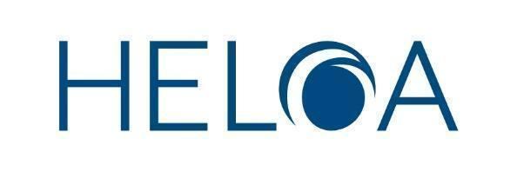
Annual General Meeting Agenda 2026
Wednesday 28th January 2026
09:30 - 12:30, online

To Note: Welcome and Introduction
Reena Littlehales, UK Chair, will outline the purpose of the AGM and explain how members can get involved.

To Note: Apologies for Absence
Alex Whitham, UK Vice-Chair (Membership and Administration), will tell members who are unable to attend.

For Discussion and Approval: Minutes of AGM, 29 January 2025, and Matters Arising
Reena Littlehales, UK Chair, will ask members to comment on activity at last year’s AGM, and will ask members to vote on these minutes as a true and accurate record of the meeting.

For Discussion and Approval: Executive Officer Reports
The HELOA Executive will outline what they, their teams, the committees, and Groups, have done this year.

4.1. Reena Littlehales, UK Chair, and the UK Committee

4.2. Raffaella Cuccia, UK Vice-Chair (Partnerships), and team

4.3. George Green, UK Vice-Chair (Group Development) and the HELOA Groups

4.4. Lauren Storey, UK Vice-Chair (Communications), and team

4.5. Alex Whitham, UK Vice-Chair (Membership and Administration)

4.6. Amy Slater-McGill, UK Vice-Chair (Governance and Policy)

4.7. Emily Day, UK Vice-Chair (Training), and team
Reena Littlehales, UK Chair, will ask members to adopt the reports as one and vote to agree that they are fair and accurate.

To Note: Report on the Election and Appointment of Officer Posts
Amy Slater-McGill, UK Vice-Chair (Governance and Policy) will tell members who was elected or appointed to committees this year.

Elected Officers

Appointed Officers
Amy Slater-McGill, UK Vice-Chair (Governance and Policy) will invite the meeting to adopt the elected and appointed officers of the association.

For Discussion and Approval: HELOA Office Report
Reena Littlehales, UK Chair, will tell members what has happened this year in the HELOA Office, and will invite members to vote to approve the report of the HELOA Office.

For Discussion and Approval: HELOA UK Committee Structure
Reena Littlehales, UK Chair, will ask members to comment and vote on the proposed motion.
The motion comes following a number of changes to how HELOA operates as a charity given sector changes and the needs of members. In increasing the office staff to full-time (February 2025) this reduces the need for certain roles and following the reduction of charity trustees a need to reframe how the UK Committee operates.
7a. Do members agree with the motion to merge the roles Vice-Chair Finance and Vice-Chair Governance and Policy into one role becoming Vice-Chair Finance & Governance?
7b. Do members agree with the motion to merge the roles Vice-Chair Group Development and Vice-Chair Membership and Administration into one role becoming Vice-Chair Membership Engagement?
7c. Do members agree with the motion to rename the UK Executive to the UK Operational Group?
As these decisions will amend the constitution, they will need to be passed by a 75% majority of votes cast at the meeting.

For Discussion and Approval: Officer Report and Financial Proposals for 2025/26
Clive Sheridan, UK Vice-Chair (Finance), will update members on the following items:

Completed accounts for the 2023/2024-2025 financial year

Membership costs for 2026/27

Proposed budget

Proposed auditor

Clive Sheridan will ask members to vote to agree that the report and accounts are fair and accurate and to approve the proposals.

For Discussion and Approval: Honorary Membership
Alex Whitham, UK Vice-Chair (Membership and Administration), will ask members to consider and vote on any nominations which have been received.

For Consideration: Any Other Business
Reena Littlehales, UK Chair, will ask members if there is anything else they would like to discuss.

To Note: Confirmation of Date of 2027 AGM & Conference - To be confirmed
Reena Littlehales, UK Chair, will formally tell members the date of the next HELOA AGM and location.

